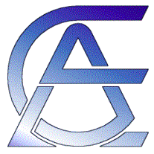
Application for a travel grant to this year’s European Crystallographic Meeting (ECM)

Name
Age
Male/female
Country
University or Institute
Highest obtained degree

Microsymposium that accepted your abstract (number and title)
Abstract submitted to the ECM
(copy paste your abstract here)

Did you register in the World Directory of Crystallographers? It is free, but it is required to be eligible for this travel grant. YES / NO
Motivation for going to the ECM
(write your text here)

This file should be submitted in electronic form (word document) to meetings.officer@ecanews.org before the deadline of 15th April of the year of the ECM applied for.

